# Mathematics Essential Name: _____Solutions____________

## Task 2.2 – Unit 2

**Assessment type:** Response - Skills

**Conditions:**

Time for the task: 30 minutes

In class, calculator permitted

**Marks:**  ______/25

**Task weighting:**

2% of the school mark for this unit

_______________________________________________________________________________

**Question 1:**

(5 Marks)

1. Write 8.3% as a decimal 0.083
2. Round 12456 to the nearest 100 12500
3. 22mL = _0.022_____ L
4. Calculate the area of a 4m by 50cm rectangular window 2m2 or 200cm2
5. If someone ran 1500m in 5 minutes what is their average speed? 300m per min or 18 km/hr

**Question 2:** (3 Marks)

Write the missing word.

1. The mode is the most _Common______ value.
2. The median is the __Middle______ value.
3. To calculate the _Mean____, you add up all the values and divide by the number of values.

**Question 3:**

**Find the mean, median, mode and range of the following data set.** (2,2,1,1, marks)

**10,66,23,45,78,9,86,32,11,66**

1. Mean: 42.6
2. Median: 38.5
3. Mode: 66
4. Range: 77

**Question 4:** (1,1, 6 Marks)

The running time, in minutes, of 16 movies at the cinema were as follows:

**123 110 98 120 102 132 112 140 120 139 42 96 152 115 119 12**

1. Order the above data set on the line below

**12, 42, 96, 98, 102, 110, 112, 115, 119, 120. 120, 123, 132, 139, 140, 153,**

Q2

Q3

Q1

1. Find the range. ________140_____________________
2. Find and label under the line above the:
3. the median (Q2) _____117________________________
4. the lower quartile (Q1) _____100_____________________
5. the upper quartile (Q3) ________127.5____________________
6. the interquartile range (IQR). _______32_____________________

**Question 5:**

A survey is conducted of the number of people in different families. The results are shown.

(3 marks)

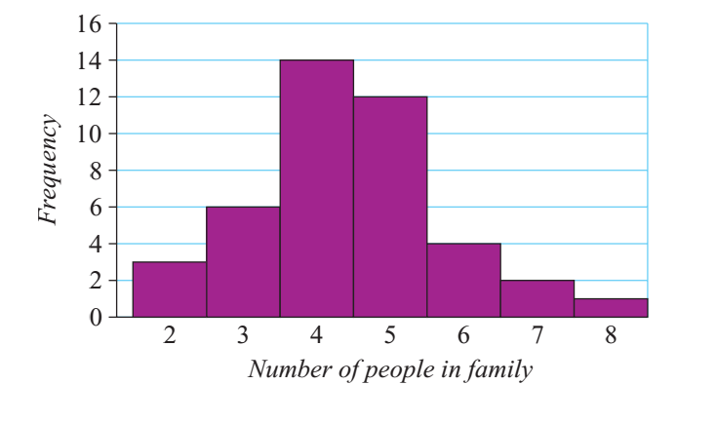

1. What is the most likely number of people in a family, on the basis of this survey? 4
2. How many people responding to the survey said they had a family of 6? 4
3. What is the least likely number (from 2 to 8) of people in a family, on the basis of this survey? 8